Pantry Pros Product and Service

According to the National Center for Education Statistics, there were about 12 million college students from the age of 18-24 in 2014. Young adults in this time frame are at a time in their life where they are learning to independently live on their own. One of the most important skills an individual can learn during this time is how to cook for themselves. With Pantry Pros, a user can download an application or use the Pantry Pros website to enter the groceries they have in their refrigerator or pantry. From here an algorithm will track what food the user has and display a number of meals the user can make using the groceries they currently own. These meals will have have recipes to follow as well as short videos showing the user how to make the meal. Inside the application there will be an option to decide how long a meal preparation will take. An example could vary from a peanut butter jelly sandwich meal a five minute meal, to chicken parmesan a fifty minute meal. Below in figure 1 is a screenshot of our beta website. Figures 2-3 are images of our competitor MyFridgeFood and in figures 4-6 ;are images of Carrot another competitor.

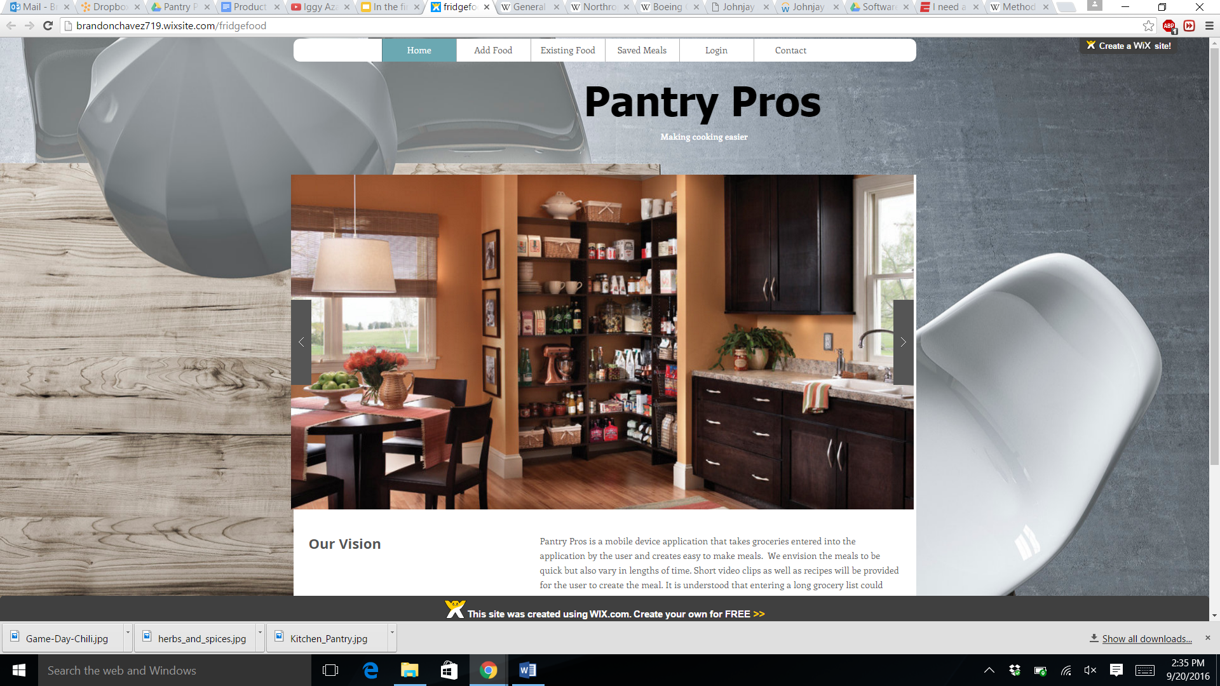

*Figure 1 - image of our beta website*

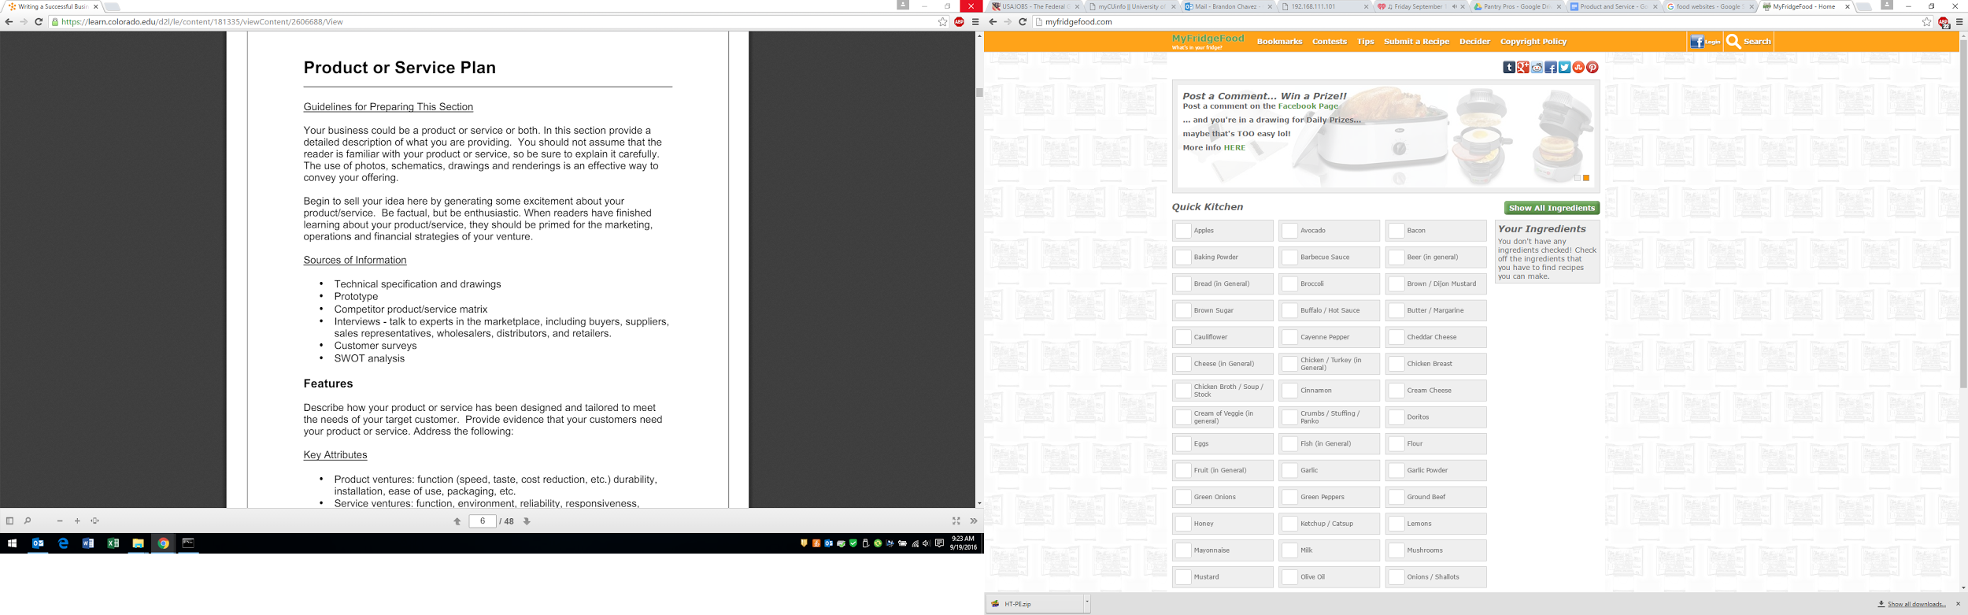

*Figure 2 - competitor MyFridgeFood website*

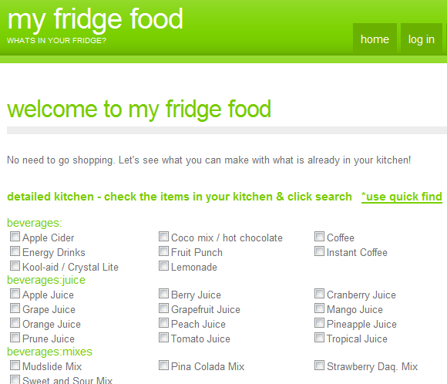

*Figure 3 - competitor MyFridgeFood app*

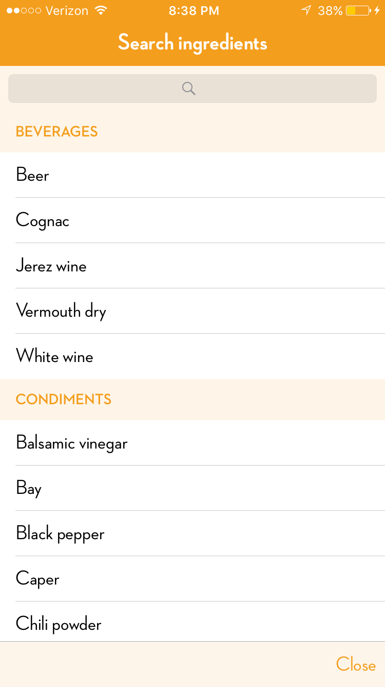

*Figure 4 - Carrot food search Figure 5 - Carrot meal option*

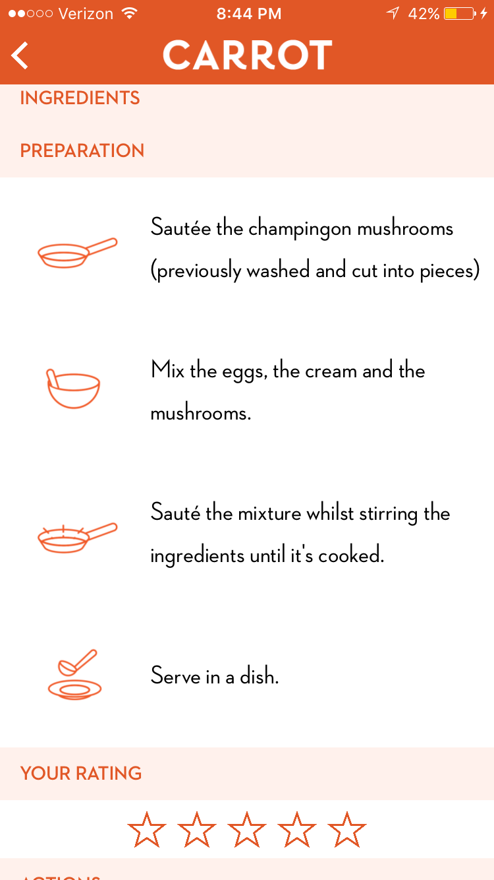

*Figure 6 -Carrot recipe layout*

**Features:**

While approaching the market, students, chefs, managers, and our competitors we have reached a conclusion that there is a desire and need for our product and the service it provides. Unlike our competitors we offer both an application they can download on their mobile device and a website that will show short clips along with recipes about how to make the meal. Having the ability to use any type of mobile device cell phone, tablet, or laptop does not limit our customer creating a sense comfort and ease. The mobile application and laptop will both have similar user interfaces similar to ones seen at grocery store self checkouts. Clicking pictures of items or typing in the name of an item will allow the user to enter their food in a simple manner. These are the features the first application release will have as more features will come in later revisions.

**Enhancements:**

In further iterations of our product we plan on adding a unique number on the bottom of grocery receipts to ease the input of groceries and food the user owns. Downloading will always be free and include in app purchases. Pantry Pros plan on targeting the customer by using social media such as facebook and instagram to target users between the ages of 18-25. In the first first few revisions we will not have technical support for errors while making food but there will be technical support for bugs in the application.

**Product/Service Strategy:**

Initially we will introduce the application to show how to make easy meals with recipes and videos. In 3 years we envision for Pantry Pros to expand its market to include older users, 30-60 years old usually having being less technical experience. The idea is to have our original target market of young adults enjoy their experience with the application and tell friends and family about how easy it was to make different food with the food that already existed in their refrigerator. Similar to Facebook, our older target market will become familiar with the product and learn to make new exciting meals. This plan could come sooner than 3 years as our older target market is already on Facebook, where our videos and advertising will be primarily based.

Our product will differentiate in many ways beginning with the way the user enters in the food. The application will also cater to all as there will be different categories ranging from: fitness, late night, date night, children, breakfast,snacks etc.using unique filtering algorithms.

To create a unique and user friendly application and website there will be many technical milestones. The first milestone will be a working mobile device application and website to use algorithms to show a number of possible meals to create. Other technical milestones will include features and benefits for the user. All these technical milestones are obtainable as all the information is available.

As any successful company it is important to evolve and stay up with the times. A possible way Pantry Pros could evolve is to offer a service like the existing company BlueApron that delivers food and a recipe to the user instead of traveling to the grocery store.

**Value Proposition:**

The Pantry Pros application and website will provide convenience for the user as they will save time and money. Instead of eating out or thinking of the different types of meals an individual can make with the food they have, the Pantry Pros product and service will provide a number of meals for them with the food they already have. Having competitors that offer a service similar to ours, it is important to give our user the best quality user experience whether they are using the mobile device application or website. This will be done similar to the way Apple attracts its customers, having an easy and visual interface.

**Proprietary Rights:**

It is hard to patent software as companies can knock off the software and reverse engineer the application. Thus a utility patent as well as design patent are not options for our product. Moving forward with our product it is important to trademark our company name as well as copyright a particular logo as branding will be an important aspect of our company as we already have a couple competitors. There is copyright information from a competitor below:

<http://myfridgefood.com/copyright-policy/>

**Stages of Development:**

The current status of our product or service is at the conceptual stage. We are planning what is important to include in the first iteration of the product before our team of programmers start. The Pantry Pros product is not ready for market yet but will be after the first release of the application and website. An advantage Pantry Pros has is the idea to have videos that show the user how to make the meal. These videos will be short 15-30 second clips similar to the “Tasty” videos seen on Facebook. Ideally it would be great to partner with a company such as “Tasty” or the Food Network to create professional videos for our product.

Appendix

RWD 2: Lurk & Learn

The target market for Pantry Pros does business through purchasing ingredients and products at grocery stores or farmers markets. With these ingredients Pantry Pros come in with services to provide recipes to put together home made meals and snacks with these purchased items. For those more experienced with food preparation, and shopping, these activities are more successful. For those less experienced It can be difficult to purchase the appropriate items for meals they plan on making themselves.

Considering Pantry Pros provides recipes for homemade meals, the best locations to observe were a non specialty grocery store, in Safeway, and the Boulder farmers market. At Safeway, customers preferences varied based on the amounts of ingredients, or food products they needed for meals that night, or buying in large amounts. Those purchasing less, seemed to have a more focused products, such as simple ingredients to cook with (onions, peppers, deli meats, seasonings). These customers needs seem to be that the store has the products/brands they need, as well as the appropriate serving sizes. Others that purchased larger amounts of products seem to be stocking their pantries with boxed, and canned items, as well as items to cook meals. These customers needs seem to be more quantity based products that will last more than a single meal. At the farmers market, the majority of the products being sold were organic fruits, and vegetables along with speciality items not found in grocery stores. This gives the impression that customers are there to buy specific items to allow them to cook predetermined meals. The farmers market also gave more organic options which seems to be important to the customers.

Observing different consumers in different situations made it apparent that that the market we are targeting is on the more inexperienced side of cooking. THis could suggest that we should have a focus on simple meals, and snack ideas when faced with limited ingredients. We also can have options to offer ideas for leftover foods, and ingredients from previous meals.

In addition to focusing on meals, and snacks when low on ingredients, we need to partner with a grocery store, or other food recipe development companies. We are going to need assistance from a company with expertise in food. We also learned that those inexperienced with cooking makes our service more attractive, yet age does not necessarily define experience with food.

Sources:

<http://nces.ed.gov/fastfacts/display.asp?id=372> - College Population